Q1(a)

SELECT column_name,data_type FROM target-382417.Target_sql_businesscase.INFORMATION_SCHEMA.COLUMNS

order by column_name

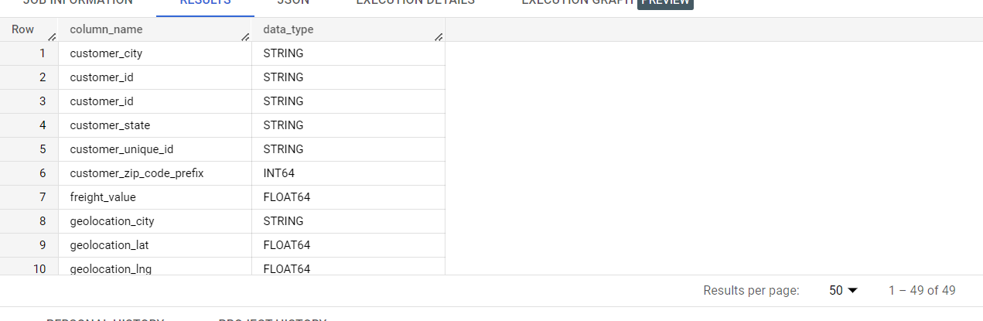

--Q1(b)

select min(order_purchase_timestamp) as First_order_purchase_timestamp,max(order_delivered_customer_date) as Last_order_delivered_customer_date

from `Target_sql_businesscase.orders`

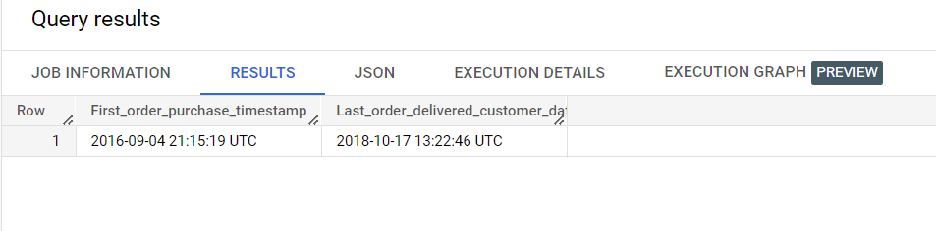

--Q1(b)with respect to review answerdate

select min(o.order_purchase_timestamp) as First_order_purchase_timestamp,max(ore.review_answer_timestamp) as Last_review_answer_timestamp

from `Target_sql_businesscase.orders` as o left  join `target-382417.Target_sql_businesscase.order_reviews` as ore

on o.order_id=ore.order_id

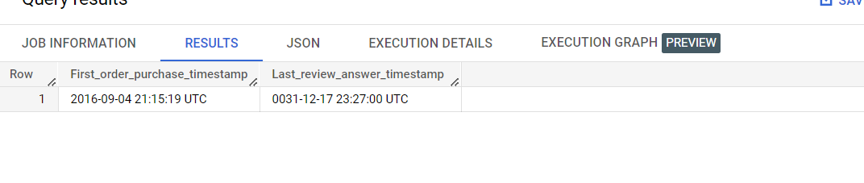

--Q1(c) every customer has done order so we can just find customer state from customer table only.

select c.customer_city,c.customer_state

from `target-382417.Target_sql_businesscase.customers` as c

join `target-382417.Target_sql_businesscase.orders` as o

on c.customer_id=o.customer_id

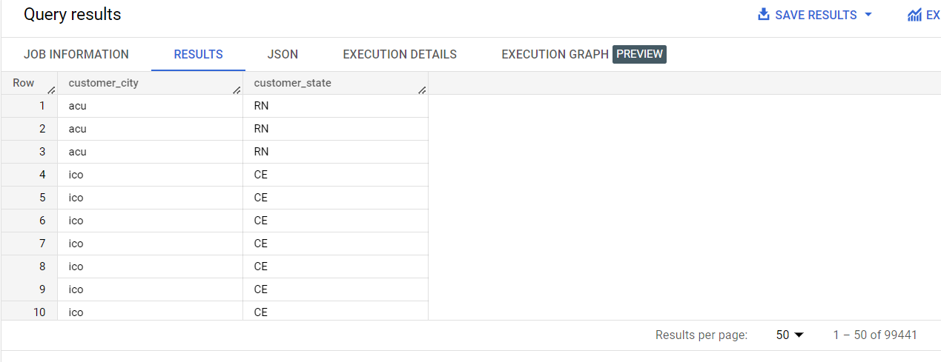

(II)Every customer has made order.

select c.customer_city,c.customer_state,o.order_id

from `target-382417.Target_sql_businesscase.customers` as c

left join `target-382417.Target_sql_businesscase.orders` as o

on c.customer_id=o.customer_id

where o.order_id is null

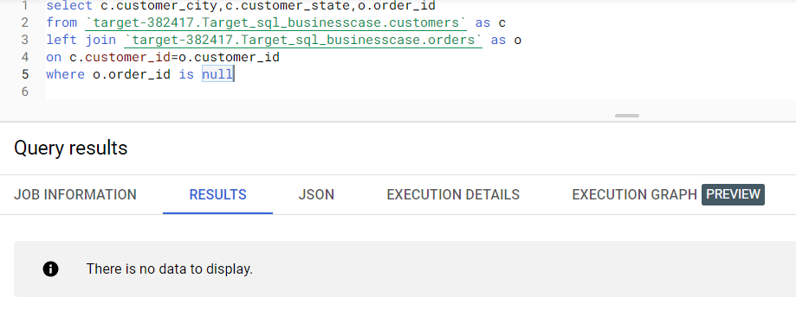

select c.customer_city,c.customer_state

from `target-382417.Target_sql_businesscase.customers` as c

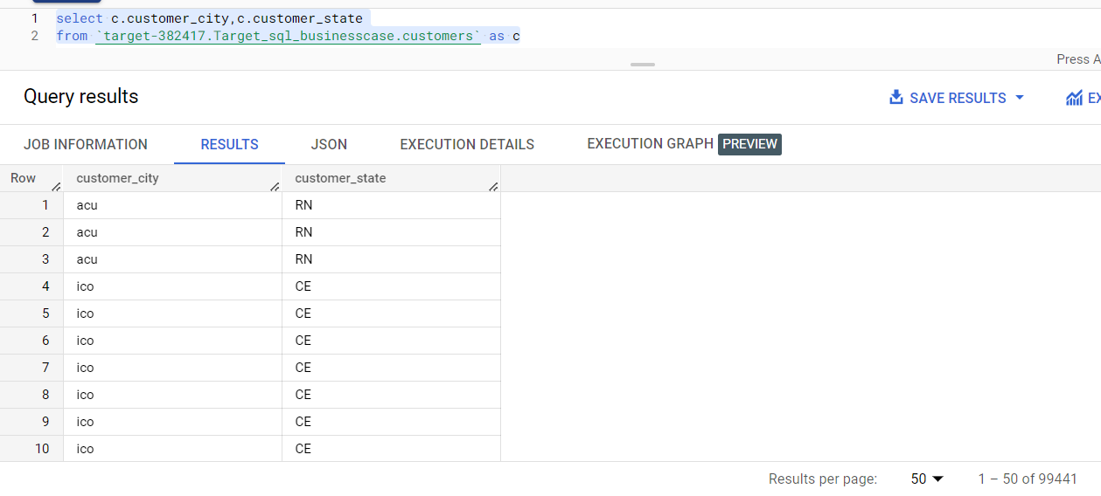

Note: Customer_id and customer_unique_id are different.

select customer_id,customer_unique_id

from `target-382417.Target_sql_businesscase.customers`

where customer_id = customer_unique_id

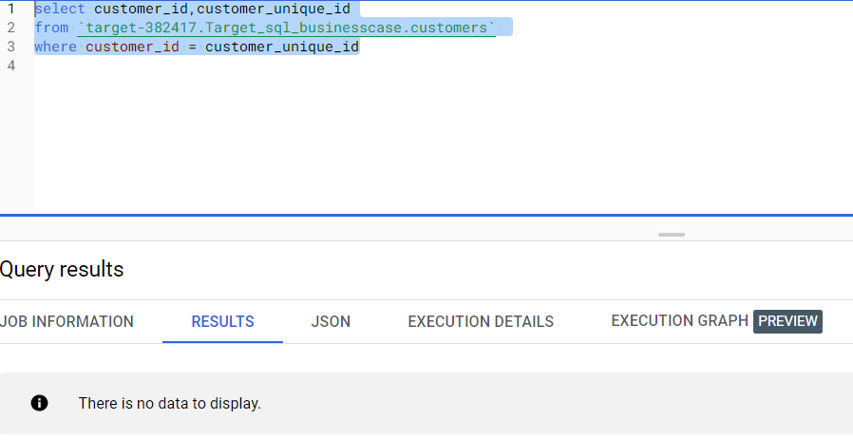

Q3(a)

select  extract(MONTH FROM o.order_purchase_timestamp) AS Month,extract(YEAR FROM o.order_purchase_timestamp) AS Year,c.customer_state,

count(distinct o.order_id) as Number_of_orders

from `target-382417.Target_sql_businesscase.orders` as o

join  `target-382417.Target_sql_businesscase.customers` as c

on c.customer_id=o.customer_id

group by Month,Year,c.customer_state

order by Year,Month

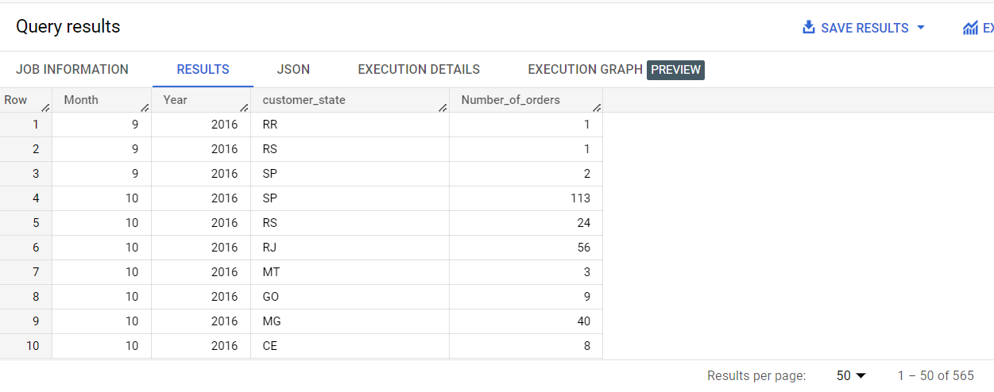

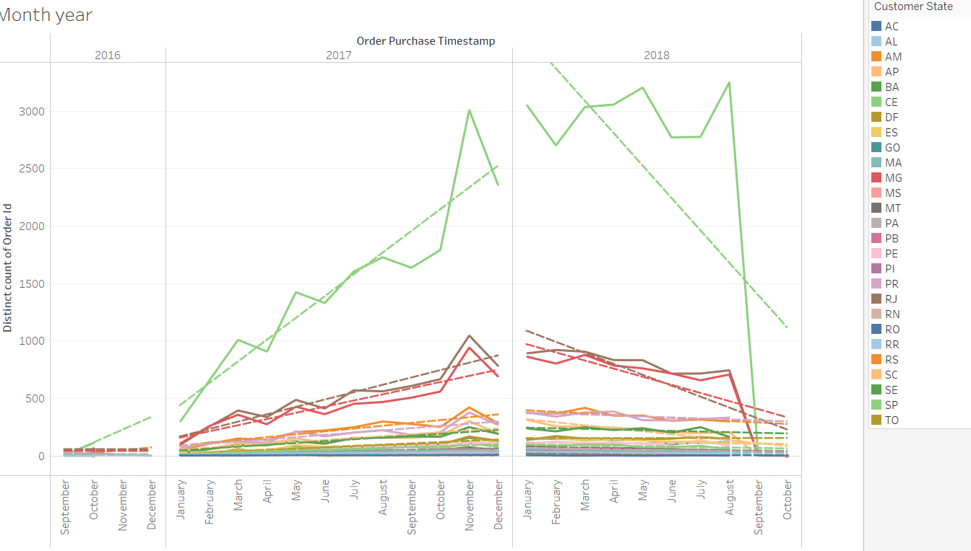

Month on month :

select extract(MONTH FROM o.order_purchase_timestamp) AS Month,c.customer_state,count(distinct o.order_id) as Number_of_orders

from `target-382417.Target_sql_businesscase.orders` as o

join  `target-382417.Target_sql_businesscase.customers` as c

on c.customer_id=o.customer_id

group by Month,c.customer_state

order by Month

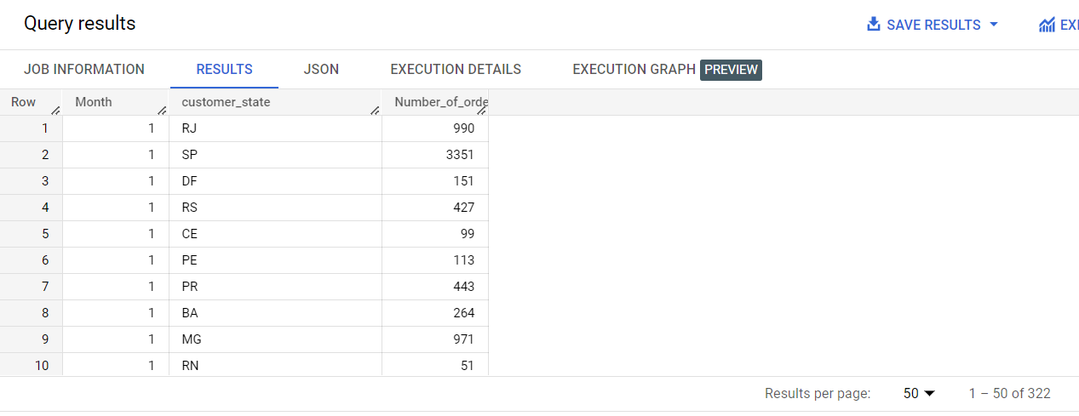

Q3(b)

select count(customer_id) as customer_id,count(customer_unique_id) as customer_unique_id,customer_state

from `target-382417.Target_sql_businesscase.customers`

group by customer_state

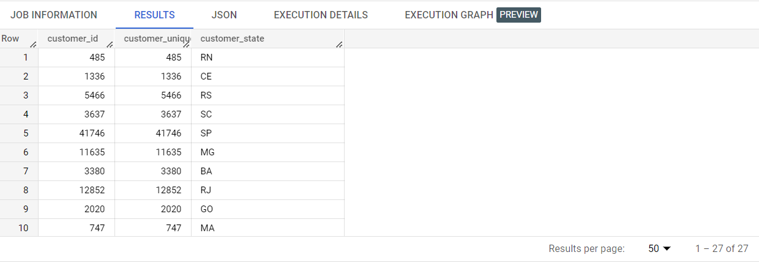

Each customer has made purchase as number of customer_id and customer_nuiqe_id are equal.

Q2(a) select extract(YEAR FROM o.order_purchase_timestamp) AS Year,

count(distinct o.order_id) as Number_of_orders

from `target-382417.Target_sql_businesscase.orders` as o

join  `target-382417.Target_sql_businesscase.customers` as c

on c.customer_id=o.customer_id

group by Year

order by Year

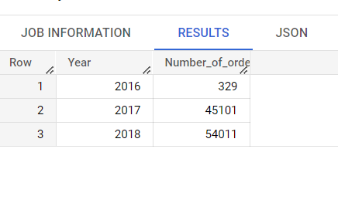

**Inner Join**

select  extract(YEAR FROM o.order_purchase_timestamp) AS Year, count(distinct o.order_id) as Number_of_orders,sum(p.payment_value) as Total_payment,

from `target-382417.Target_sql_businesscase.orders` as o

join  `target-382417.Target_sql_businesscase.payments`as p

on o.order_id=p.order_id

group by Year

order by Year

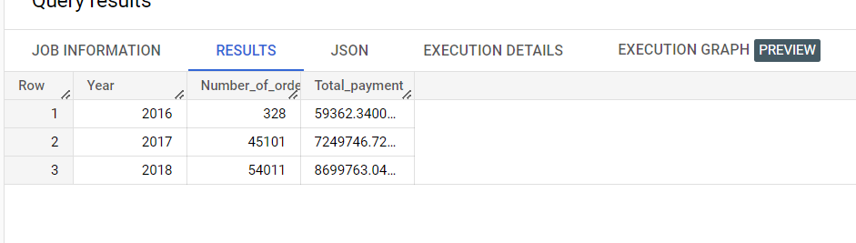

Note: One order has not received payment

**Left join code**

select  extract(YEAR FROM o.order_purchase_timestamp) AS Year, count(distinct o.order_id) as Number_of_orders,sum(p.payment_value) as Total_payment,

from `target-382417.Target_sql_businesscase.orders` as o

left join  `target-382417.Target_sql_businesscase.payments`as p

on o.order_id=p.order_id

group by Year

order by Year

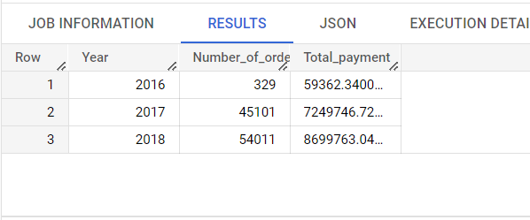

Q4(a)

SELECT c.customer_state,sum(oi.price) as Price,sum(oi.freight_value) as Freight_value,sum(price+freight_value)as Sum_Price_Freight,

AVG(oi.price) as Mean_price,AVG(oi.freight_value) as Mean_freight,

AVG(price+freight_value) as Mean_Price_Freight

from

`target-382417.Target_sql_businesscase.customers` as c

join

`target-382417.Target_sql_businesscase.orders` as o

on o.customer_id=c.customer_id

left join

`target-382417.Target_sql_businesscase.order_items` as oi

on o.order_id=oi.order_id

group by c.customer_state

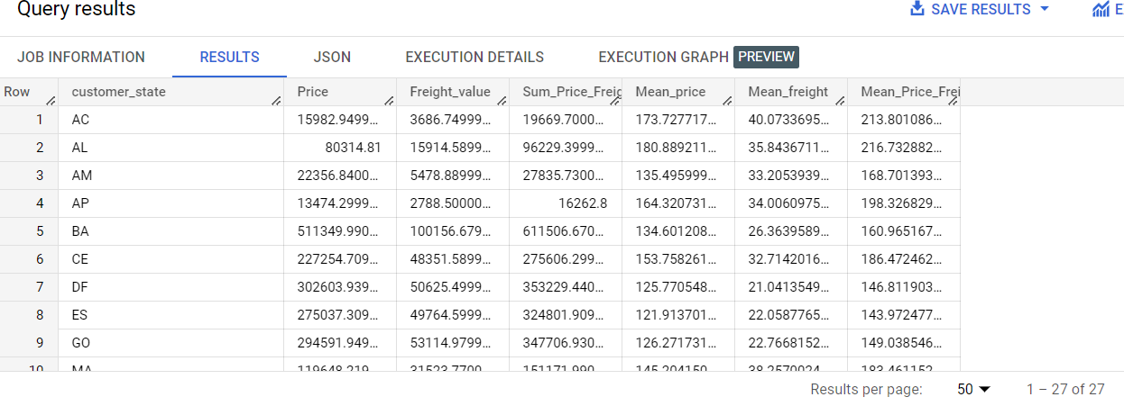

**With inner join price with null values will not impact on sum and mean. So both will give same output.**

SELECT c.customer_state,sum(oi.price) as Price,sum(oi.freight_value) as Freight_value, sum(price+freight_value)as Sum_Price_Freight,

AVG(oi.price) as Mean_price,AVG(oi.freight_value) as Mean_freight, AVG(price+freight_value) as Mean_Price_Freight

from

`target-382417.Target_sql_businesscase.customers` as c

join

`target-382417.Target_sql_businesscase.orders` as o

on o.customer_id=c.customer_id

join

`target-382417.Target_sql_businesscase.order_items` as oi

on o.order_id=oi.order_id

group by c.customer_state

order by c.customer_state

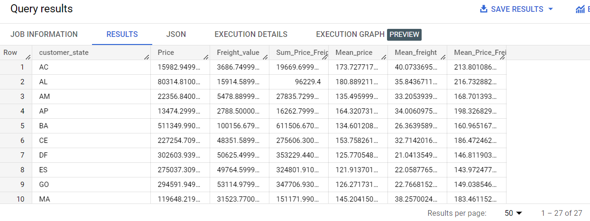

Q. 6(a)

Select  extract(Month from o.order_purchase_timestamp) AS Month, p.payment_type as Payment_Types,

count (distinct p.order_id) as Num_Orders

from `target-382417.Target_sql_businesscase.payments`as p

join

`target-382417.Target_sql_businesscase.orders` as o

on o.order_id=p.order_id

group by Payment_Types,Month

order by Payment_Types, Month

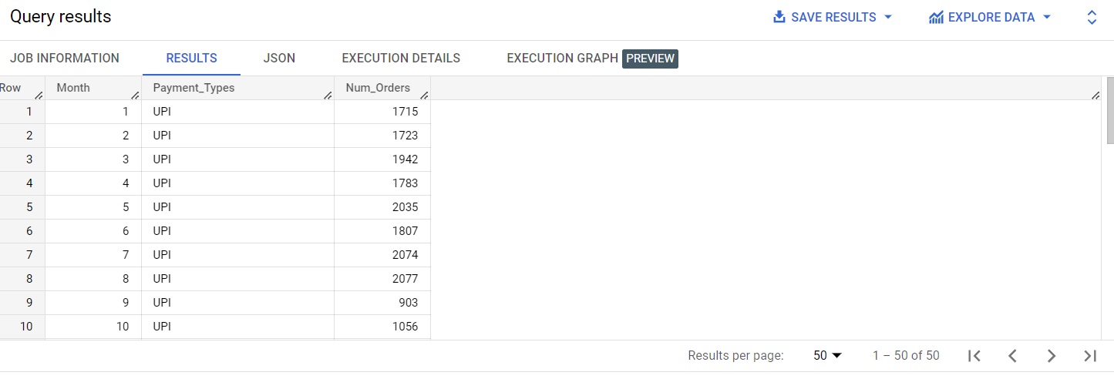 select department_id as Department, count(employee_id) as No_of_employees,

Case

when count(employee_id)=1 then "Junior Department"

when count(employee_id)<=4 then "Intermediate Department"

when count(employee_id)>4 then "Senior Department"

End As  Department_level

from employees

group by department_id

order by No_of_employees,Department

select department_id as Department, count(employee_id) as No_of_employees,

Q. 6(b)

Select  p.payment_installments as Num_Payment_Installments, count (distinct p.order_id) as Num_Orders

from `target-382417.Target_sql_businesscase.payments`as p

group by Num_Payment_Installments

order by Num_Payment_Installments

